## **Exercise 1: Singleton Pattern (Logger Class)**

### **1. Project Name: SingletonPatternExample**

### **2. Files:**

#### **i)Logger.cs**

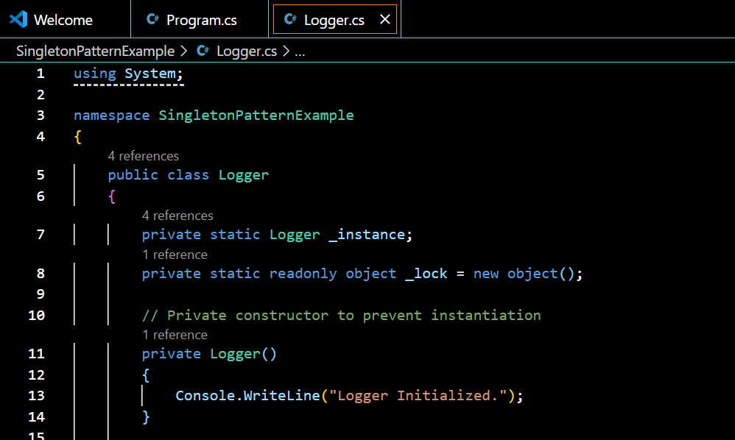

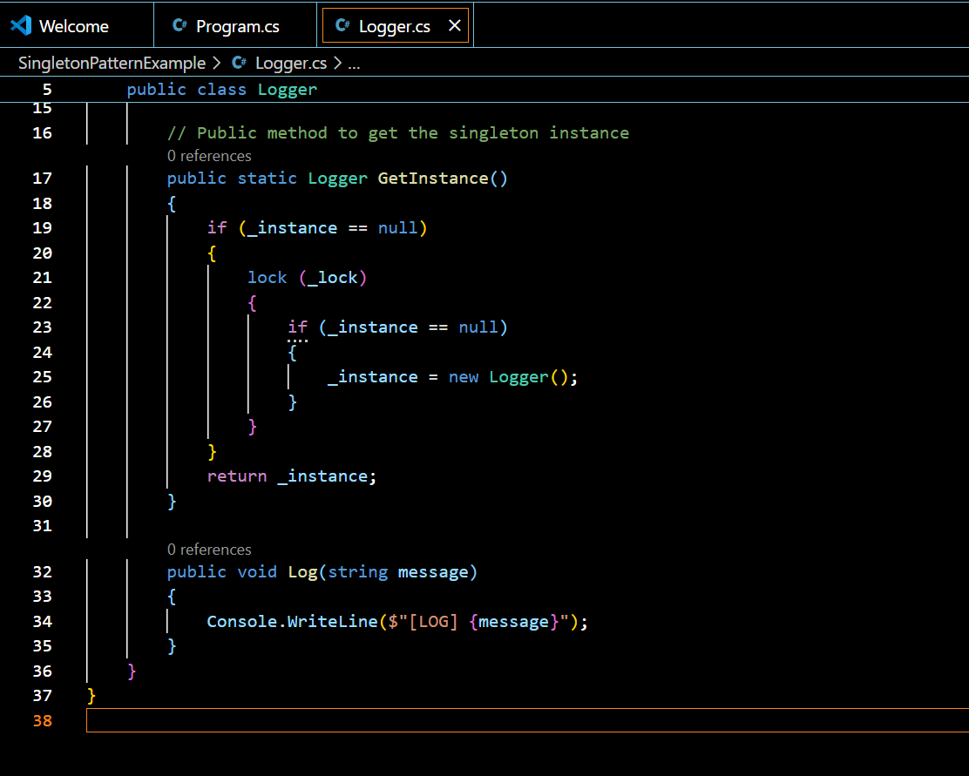

#### **ii)Program.cs (Test Singleton)**

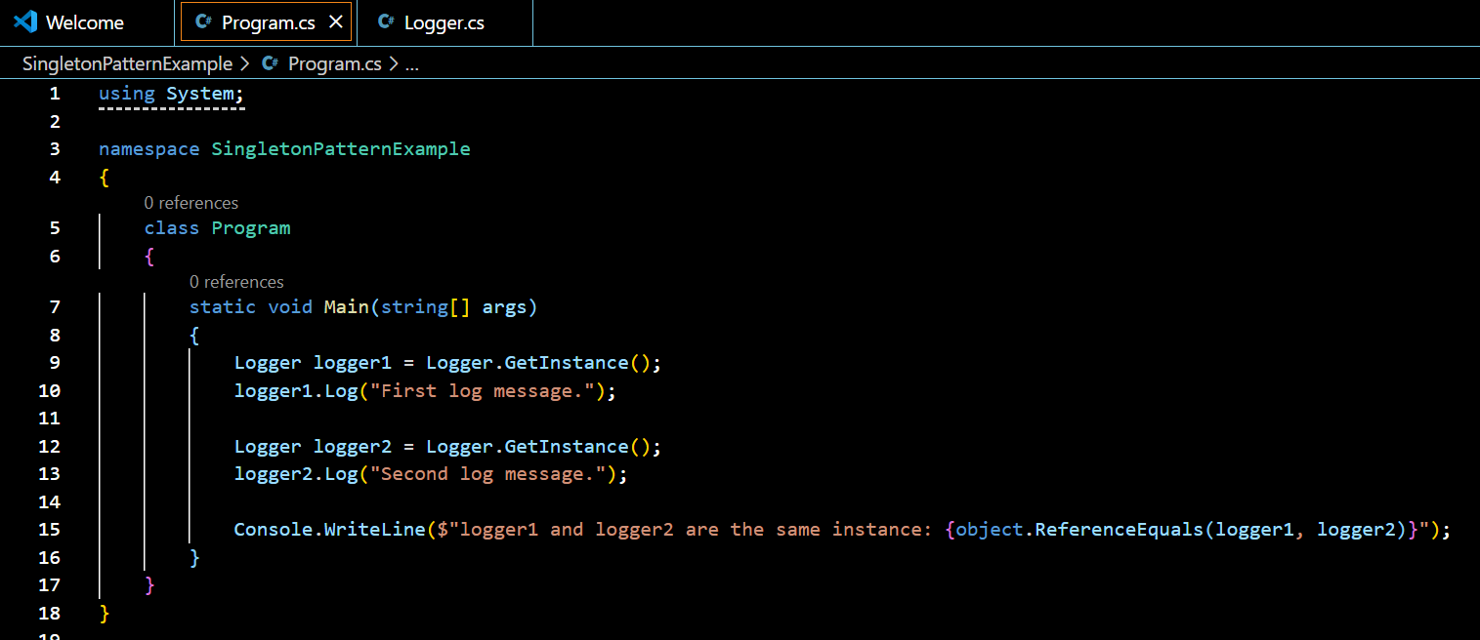

### **3.Output:**

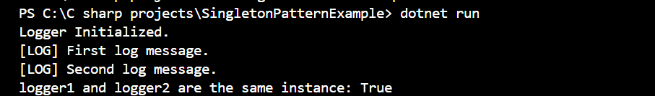

## **Exercise 2: Factory Method Pattern (Document Creation)**

### **1. Project Name: FactoryMethodPatternExample**

### **2. Files:**

#### **i)IDocument.cs**

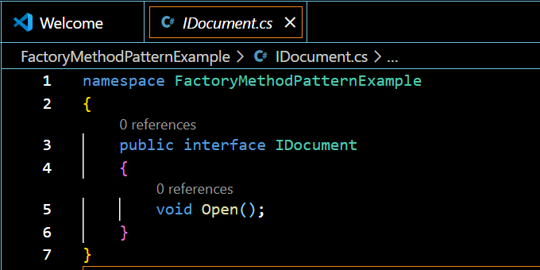

#### **ii)Concrete Documents:**

##### **a)WordDocument.cs**

##### **b)PdfDocument.cs**

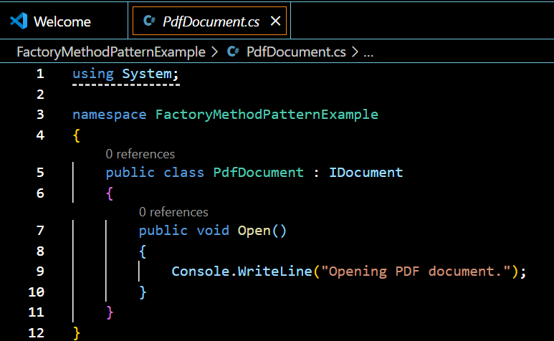

##### **c)ExcelDocument.cs**

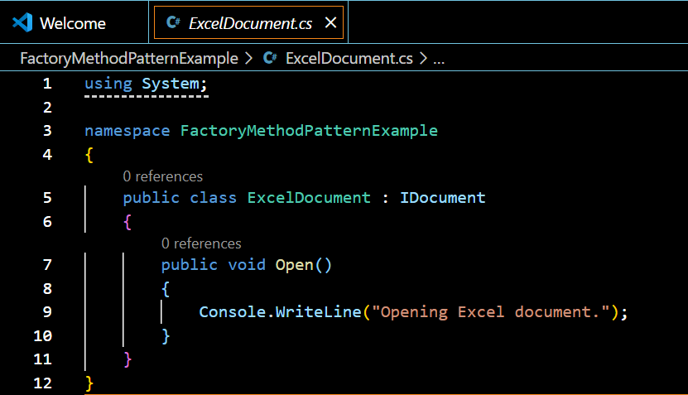

##### **d)Factory Classes:**

###### **i)DocumentFactory.cs**

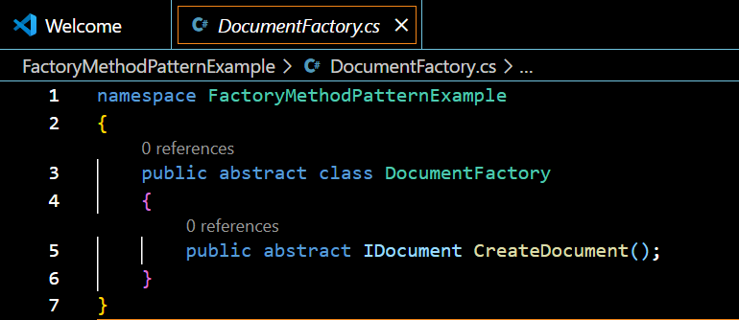

###### **ii)WordDocumentFactory.cs**

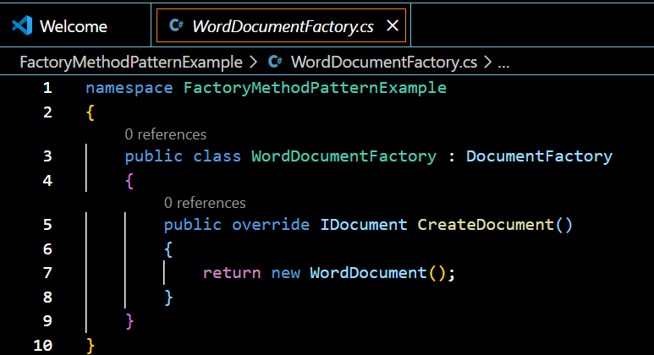

###### **iii)PdfDocumentFactory.cs**

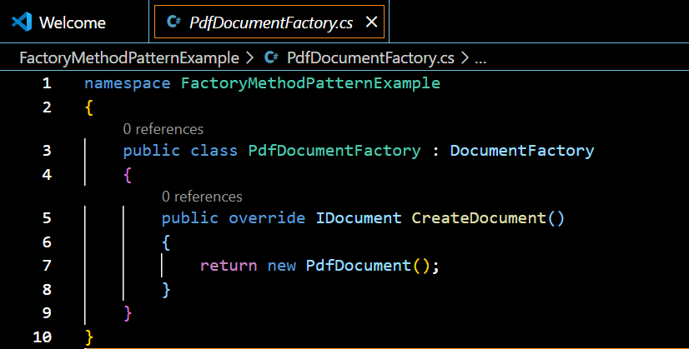

###### **iv)ExcelDocumentFactory.cs**

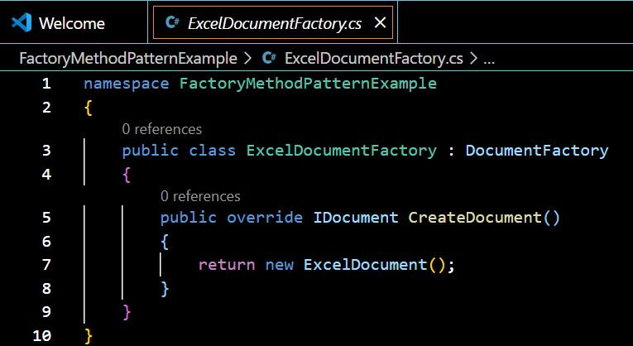

#### **iii)Program.cs (Test Factory Method)**

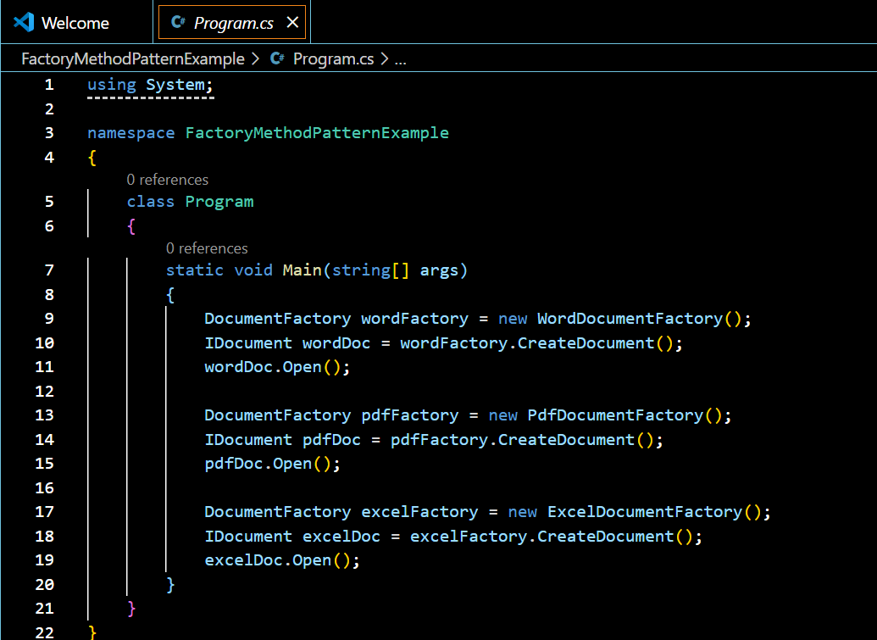

### **3.Output**

